RESEARCH PROTOCOL

Full Title: Correlation between Low Ferritin and Tachycardia subtypes in Jordanian Population

Short Title: Low Ferritin and Tachycardia

STUDY INVESTIGATOR(S)
Miss Nazerah A. Yaseen
Dr. Malik M. Khalil
Dr. Raed M. Kanan

Principal Investigator(s):
Nazerah A. Yaseen  Medical Technologist / Genetics  Research and development  Biogen Medical laboratories  Ph. 0799215224  Email: Nazerah.warrad8495@hotmail.com  [Study Design, Research and analysis] | Dr. Raed M. Kanan  Medical Geneticist (PhD)  Lab Director  Biogen Medical Laboratories  Ph. 0799200320  Email: info@Biogen.dr-kanan.com  [Study Design and Analysis ]

Dr. Malik M. Khalil

Medical Doctor (Heart internist)

[unit/d

[org]

[address]

Ph. xxxxxxxxxx

Email: xxxxxxxxxx@xxxxxxxxxx

[recruitment]

INTRODUCTION

Tachycardia is heart arrythmia disease characterized by increase heart rate, which may lead to death. It is the cause of 150,000 to 300,000 out of hospital sudden deaths that occur annually in the US. Tachycardia can result from a wide range of physiological conditions including damage to the heart, stress, exercise and anemia. Anemia is common condition where low red blood cells or hemoglobin is observed. This may be due to different reasons such as iron deficiency, vitamin B12 deficiency, hemolysis and blood loss. Studies has shown that iron deficiency related to increased heart rate. Iron is stored in the body as ferritin. However, there is no studies showed a relationship between low ferritin and increase heart rate or tachycardia. In this study, we investigate the possibility of correlation between low ferritin and tachycardia.

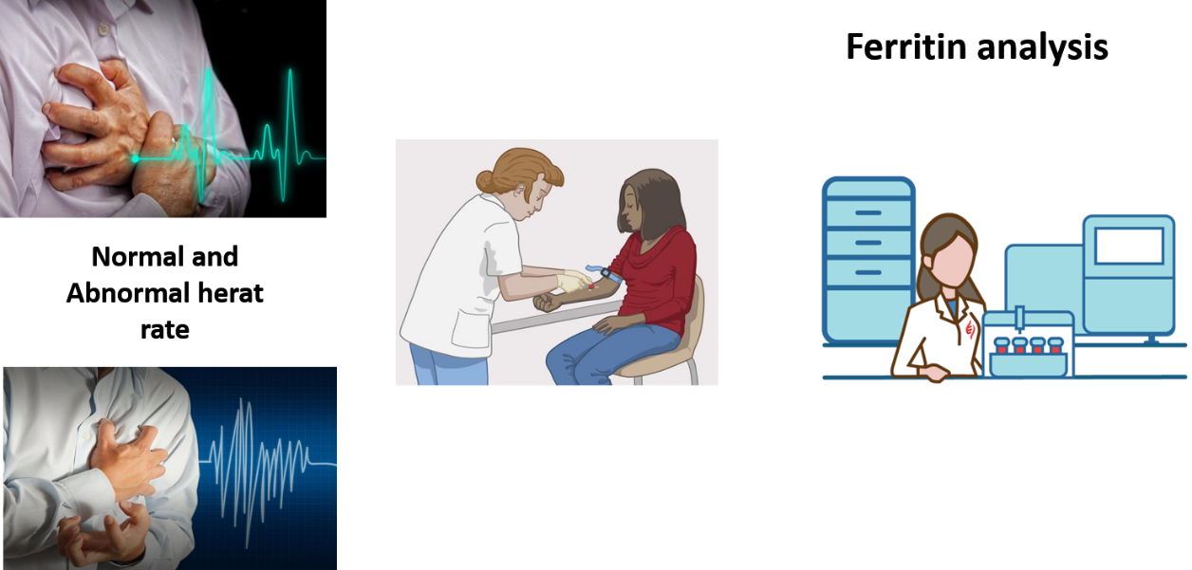

BACKGROUND

Tachycardia is known as increase heart rate and has many types depend on number of heart beats and/or changes in the heart rhythm. Tachycardia can cause sudden death, in fact, in USA it counts for 150,000 to 300,000 of hospital sudden deaths every year.

1-Ventricular Tachycardia defined as abnormally rapid heart rate, usually taken to be over 100 beats per minute. Tachycardia could produce a broad QRS rhythm.
Ventricular Tachycardia can be divided into many types including:

-Benign ventricular tachycardia originating in the ventricles, not associated with structural heart disease or significant hemodynamic symptoms.
-Bidirectional ventricular tachycardia (bifascicular ventricular tachycardia) a ventricular arrhythmia characterized by heart rates of 90 to 160 beats per minute, alternating right and left axis deviation, ectopic focus that alternates between the anterior superior and posterior inferior fascicles, and a right bundle branch block pattern in lead V1; seen in digitalis toxicity and other conditions.
2-Atrial tachycardia is a rapid heart rate, between 140 and 250 beats per minute, with the ectopic focus in the atria and with no participation by the atrioventricular node or the sinoatrial node. It is recognizable on the electrocardiogram because the P wave precedes the QRS complex, as opposed to being merged with it or following it. This condition is usually associated with atrioventricular block or digitalis toxicity.

3-circus movement tachycardia (CMT) a reentry circuit that uses an accessory pathway or pathways; there are two subtypes, antidromic and orthodromic circus movement tachycardia.
4-ectopic tachycardia rapid heart action in response to impulses arising outside the sinoatrial node.
5-junctional tachycardia rhythm at the rate of 100 to 140 beats per minute that arises in response to impulses originating in the atrioventricular junction, i.e., the atrioventricular node. It is often seen with digitalis toxicity and is due to triggered activity, but it may also be due to altered automaticity. In the case of digitalis toxicity, the term may be used to encompass the entire span of junctional rates with this condition, i.e., approximately 70 to 140 beats per minute.
6-monomorphic ventricular tachycardia a type that has a uniform beat-to-beat QRS morphology.
7-nonsustained ventricular tachycardia a type that terminates spontaneously within 30 seconds and does not lead to hemodynamic collapse.
8-orthodromic circus movement tachycardia a supraventricular tachycardia supported by a reentry circuit that uses the atrioventricular node in the anterograde direction and an accessory pathway in the retrograde direction, producing a narrow QRS complex.
9-orthostatic tachycardia disproportionate rapidity of the heart rate on arising from a reclining to a standing position.
10-paroxysmal tachycardia rapid heart action that starts and stops abruptly.
11-paroxysmal atrial tachycardia paroxysmal supraventricular tachycardia.
12-paroxysmal supraventricular tachycardia (PSVT) a narrow QRS tachycardia that begins and ends abruptly; it may be terminated with a vagal maneuver. It has two common mechanisms, atrioventricular nodal reentry and circus movement that uses the atrioventricular node anterogradely and an accessory pathway retrogradely. On the electrocardiogram it is characterized by abrupt onset, and mechanisms are differentiated by the relation of the P wave to the QRS complex.
13-polymorphic ventricular tachycardia a type that has a constantly, and sometimes subtly, changing beat-to-beat QRS configuration.
14-potentially malignant ventricular tachycardia a type that is not associated with structural heart disease or hemodynamically important cardiac symptoms but is sometimes associated with left ventricular dysfunction.
15-sinus tachycardia (ST) a rapid rhythm originating in the sinoatrial node with a rate of usually 100 to 160 beats per minute; conduction through the ventricles is normal. During exercise or stress this is normal, but if it occurs during rest it is abnormal.
16-supraventricular tachycardia a combination of junctional tachycardia and atrial tachycardia.
17-sustained ventricular tachycardia that lasts more than 30 seconds and leads to hemodynamic collapse.

Tachycardia can be caused by many things like damage to heart tissues from heart disease , Abnormal electrical pathways in the heart present at birth (congenital heart conditions, including long QT syndrome), Disease or congenital abnormality of the heart, Anemia, Exercise, Sudden stress, such as fright, High or low blood pressure, Smoking, Fever, Drinking too much alcohol, Drinking too many caffeinated beverages, Medication side effects, Abuse of recreational drugs, such as cocaine, Imbalance of electrolytes, mineral-related substances necessary for conducting electrical impulses, Overactive thyroid (hyperthyroidism).
An important cause of tachycardia is anaemia, mainly the type that associated with iron deficiency. Iron deficiency

The most important aspect of a research proposal is the clarity of the research problem.
This is an opportunity to convince the reader (or reviewer) of why the study needs to be done (and deserves funding or ethical approval). Keep this brief and to the point (approximately two A4 pages). The following key points may be used as a guide:
- Conduct a comprehensive literature search (Cochrane, Medline, Embase and other databases relevant to your area of study).
- Discuss the importance of the topic (public health and/or clinical importance and impact on individuals/community; incidence, prevalence, mortality and morbidity).
- Critically appraise the relevant literature and discuss the state of current knowledge on the topic (including deficiencies in knowledge or gaps that make the study worth doing).
- Indicate how the research question has emerged and fits logically with the above.
- Outline your approach to address the research question.
- Explain how your study will contribute to existing research and benefit other individuals or the wider community.

Discussion should be clear and logical that demonstrates you are fully conversant with the ideas presented and can grasp their methodological implications. Aim to be concise and present only key sources rather than an exhaustive list of cited references (limit to approximately 20-25 key papers). The literature review should logically lead to the statement of the aims of the proposed project.

AIM OF STUDY / RESEARCH QUESTIONS

Your aim(s) should arise from your literature review and state what the study hopes to accomplish.

Your focused research question(s) may need to be further refined as one or more study objectives. The study objective(s) should be single and quantifiable statement(s) that will allow you to answer your research question(s).

e.g. The objective of this study is to determine if socioeconomic status is associated with excess childhood asthma in Istanbul.

HYPOTHESIS (for quantitative studies)

Hypotheses are more specific than objectives and amenable to statistical evaluation. Your primary hypothesis is your statement of the hypothesised effect on the primary outcome measure. A hypothesis is worded very simply and written as ‘testable’ statements. Your experimental results will prove or disprove your hypothesis. Hypotheses are generally stated in the null form (H_{o}) as they have their basis in inferential statistics. Rejecting the null hypothesis increases our confidence, with a given level of probability, that there is a relationship between the variables being studied. However, a classic scientific hypothesis includes both a null and alternative (H_{a}) hypothesis.

e.g. H₀: Asthma prevalence rates are not different among children from low and high socioeconomic groups in Istanbul.

H_{A}: Asthma prevalence rates are different among children from low and high socioeconomic groups in Istanbul.

STUDY DESIGN

State the design of the research (e.g. randomised controlled study, cross-sectional survey, prospective or retrospective cohort/case-control, observational, focus groups/interviews, action research).
Whatever the study design, you need to ensure that you provide the reader with a clear statement and description of your proposed design. You may also explain why the particular study design has been chosen in preference to other possible designs (i.e. justification for choice of study design).

STUDY SETTING/LOCATION

The location of where the study will be conducted (e.g. Neonatal Intensive Care Unit, Riverland Region). You need to mention whether the study is going to be a single-centre study or a multi-centered study (i.e. conducted in more than one location).
- Sites

Include all involved in the study (e.g. where the participants will be recruited, where the data will be stored, who is initiating the research, who is providing data, etc).

Example:

- SA Department for Health and Ageing (e.g. centrally held data)
- Lyell McEwin Hospital, SA
- SA Ambulance Service
- Port August Hospital, SA
- Flinders University
- Attorney General’s Department
- SA-NT Datalink

STUDY POPULATION AND SETTING

You need to describe the population that will be targeted to participate in the study. It is important to outline:
- The population the participants will be drawn from
- All aspects of participant selection
- The total number and number within any subgroups

If you are undertaking quantitative research, this section also describes how one can be certain that the results from your sample population can be generalised to the target population of interest. If your research is qualitative, describe what makes the selection of this particular population and site sound, in terms of its interest, richness, diversity, likelihood of success etc. Also, you need to describe the way in which you will sample for participants (typical case, snowball, theory-based etc.)

ELIGIBILITY CRITERIA

Inclusion and exclusion criteria are standards that you have set determining whether a person may or may not be allowed to enter your study. They are used to identify appropriate participants and to ensure their safety.
- Inclusion criteria

- E.g. Asthma-related hospital admission
- E.g. Admitted between **/**/**** and **/**/***
- E.g. Ages =>18 years
- E.g. English speaking
- Exclusion criteria

Provide details of participants that will be considered ineligible to participate and justification for their exclusion. These criteria are not always clinical in nature, aiming principally to accommodate participants in a safe and ethical manner. Criteria may include :
- circumstances that interfere with the participant’s ability to give informed consent (diminished understanding or comprehension, or a language other than English spoken and an interpreter unavailable),
- contraindications to the study treatment(s)/procedure(s),
- taking certain concomitant medication(s), or conditions that interfere with a patient's ability to comply with all treatment(s)/procedure(s). or follow study guidelines.
- E.g. Ages <18 years

STUDY OUTCOMES
- Quantitative

- Primary Outcome

The primary outcome should be the most important and clinically relevant outcome (e.g. clinical, psychological, economic, or other) of the study. This is the measure used to answer your study aim. However, it is also the outcome used to calculate study sample size and power and test the primary research hypothesis. Generally, no more than 1-2 primary outcome measures are pre-specified. Primary outcome measures may be measured in various ways such as:
- binary (e.g. caesarean/no caesarean, blood loss ≥500mL/blood loss <500mL);
- continuous (e.g. weight - kg, blood loss - mL);
- ordinal (e.g. pain - mild, moderate, severe);
- time to event (e.g. survival)
- counts (e.g. number of infections, number of events occurring).

- Secondary Outcome(s)

Secondary outcome(s) are measures of additional or less important research interest. They may include additional clinical, psychological, economic, or safety outcomes (e.g. treatment related side effects/adverse events). However, as these endpoints are not used to calculate study power and sample size it is often not possible to draw robust conclusions from the results.
- Qualitative

You should describe the form that you expect your findings to take (presentation of themes, critical episode presentation, life history) and the way in which you will present these (report, papers for publication, conference presentation, feedback to participants etc.)

STUDY PROCEDURES

This section should describe exactly what is going to happen during conduct of the study. It is preferable to use the active voice and state in the future tense (e.g. “We will randomly allocate participants to…”).
- Recruitment of participants

This section should describe which potential participants will be identified/selected for recruitment (e.g. via outpatient clinic), how they will be approached/invited to participate and how consent will be obtained. You may need to justify the feasibility of recruiting the required number of participants and estimate the proportion that you would expect will agree to participate. Finally, the period of time expected to recruit the required number of participants should be stated here.
- Study procedures

In this section you need to clearly and comprehensively describe exactly what will happen to participants once they are enrolled in your study. Depending on the study it might include when they will be randomised, the frequency and duration of visits or whether they are expected to self-complete a daily diary at home, the duration of the study or follow-up, if they will take part in a focus group, and any measurements taken at each visit (e.g. questionnaires, physical measurements, biological samples).

You should include precise details of any intervention(s) intended for each group/participant including the time each study visit (interview, questionnaire, test) will take and what is involved. You should also provide details of any follow-up and consider how you will monitor ongoing participation if applicable. You might also describe under which circumstances participants may withdraw or be withdrawn by the investigators and how this will occur. A schematic diagram or flow chart may be useful for this section.
- Methods of data collection

It is essential to state how the data will be collected to assess the outcome(s) of the study (e.g. patient questionnaire, interview, focus group, medical charts, routinely collected hospital case notes/ databases, biological specimens).

Describe at what point(s) of the study data collection will occur. You should make statements that justify the validity of the study measure/instrument and/or whether there will be audio recordings. If not, you will have to verify how you will ensure the validity and quality of data being collected. Also, mention here if you are going to have one or more assessors to collect data, their level of training/experience (or how they will be trained), and if you are planning to assess inter-rater reliability (if applicable).
- Access to Existing Data

This section includes information on the data variables requested where accessing existing data. If not applicable, the table can be removed and replaced with a N/A.

Name/Description of data | Flinders Medical Centre Medical Records
Data Custodian | Flinders Medical Centre
Agency Type | Institution (Institutional / State / Commonwealth / Private Sector)
Data Collection Format | Identifiable (identifiable / re-identifiable / non-identifiable)
Variable | Justification
Patient_ID
Name
Date of Birth
Address
Surgeon
Age at time of surgery
Ethnicity
Smoking History

Name/Description of data | Integrated South Australian Activity Collection (ISAAC)
Data Custodian | SA Department for Health and Ageing
Agency Type | State (Institutional / State / Commonwealth / Private Sector)
Data Collection Format | re-identifiable (identifiable / re-identifiable / non-identifiable)
Variable | Justification
Patient_ID
Hospital
Postcode
Date_Of_Death
Age_At_Admission
Indigenous_Status
Country_Of_Birth | Country of birth is a required statistic in reporting the demography of the study population.
Admission_Date
Principal_Diagnosis
Marital_Status | Marital status is a required statistic in reporting the demographic of the study population.
Employment_Status
Pension_Status
Admission_Category

Name/Description of data | Perinatal Statistics Collection
Data Custodian | SA Department for Health and Ageing
Agency Type | State (Institutional / State / Commonwealth / Private Sector)
Data Collection Format | re-identifiable (identifiable / re-identifiable / non-identifiable)
Variable | Justification
Patient_ID
Hospital
Age_At_Presentation
Postcode
Date_Of_Death
Arrival_Mode | Mode of arrival is required to account for any additional cost incurred due to the transport mode.
Country_Of_Birth | Country of birth is a required statistic in reporting the demography of the study population.
Diagnosis
Departure_Status | Departure status is required to understand patient's status at the end of the emergency care and related to URG classification.
Indigenous_Status
Triage_Category
Presentation_Date

Name/Description of data | SA Deaths Registry
Data Custodian | SA AttorneyGeneral's  Department
Agency Type | State (Institutional / State / Commonwealth / Private Sector)
Data Collection Format | re-identifiable (identifiable / re-identifiable / non-identifiable)
Variable | Justification
Age at Death Age
Date of Death
Cause of Death 1A
Cause of Death 1B
Cause of Death 1C
Cause of Death 2A

- Data Linkage Management

Data linkage allows for the identification of distinct entities within datasets and between
datasets. If data linkage is occurring in your study, specific detail is required on how the linkage will occur including who will manage the linkage (e.g. SA-NT datalink) and how participants’ privacy and confidentiality will be protected, if not already described under heading ‘Study procedures’.

Consider how your findings account for any limitations arising from your choice of datasets/databases or from missing data?

Consider how will you manage any risk that linking databases of non-identifiable data could subsequently result in the individuals being identified?

The HREC encourage including a flow diagram which depicts the data linkage process.

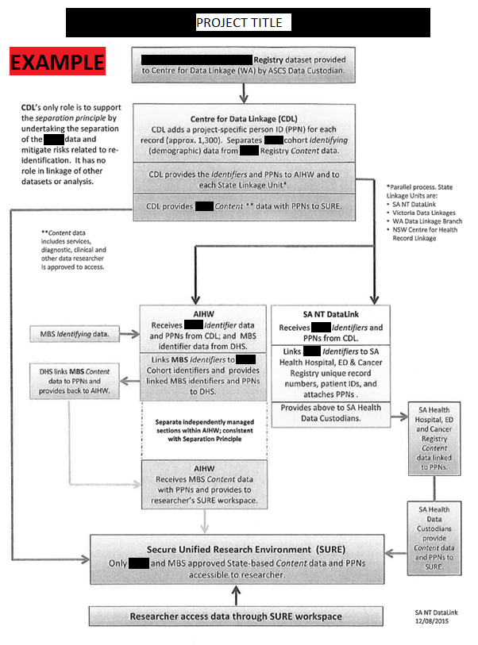
- Safety considerations

The safety of research participants is foremost. You will need to provide adequate information on how the safety of research participants will be ensured, drawing attention to any relevant sections of the National Statement. This can include procedures for recording and reporting serious adverse events and their follow-up. Remember that even administering a research questionnaire or conducting an interview may have adverse psychological effects on susceptible individuals. Also keep in mind that your research may have impacts on whole populations; you need to consider whether the findings of your research may harm communities if they are reporting inappropriately.

Safety considerations also apply to the safety and wellbeing of researchers (for example, if they are doing home visits, if they are working with dying patients, mental health patients , etc).
- Data monitoring

This section includes information on the personnel and processes of person or groups monitoring the study, study monitors to audit study conduct, any stopping and discontinuation rules and handling of adverse events/serious adverse events.

DATA ANALYSIS
- Quantitative

- Sample size and statistical power

A sample size or power calculation should be performed. This calculation is used to estimate the number of participants required to answer your primary study hypothesis with an accepted power. Conversely, it also allows you to estimate what power can be achieved with a limited number of participants. This number is calculated by specifying the magnitude of the effects that are expected (i.e. informed and clinically significant), variability of the measurements and the acceptable degree of type I and II errors. You need to specify the assumptions made for the calculation. It is recommended that you consult with a statistician for this section. Also keep in mind the estimated recruitment rate and whether you need to adjust for anticipated non-responders and losses to follow up.

- Statistical methods

The statistical methods used for the study objectives/hypotheses (e.g. t-test, chi-squared, multivariate modeling) must be sufficiently detailed. If conducting a randomized controlled study, you should state whether methods will include an “intention to treat” (ITT) analysis, per protocol analysis, or both. An ITT analysis is preferred as it compares all participants in the groups to which they were originally randomly assigned (despite withdrawal, treatment failure or cross-over). Consultation with a statistician is strongly recommended.
- Qualitative

The analysis strategy adopted in qualitative research will relate to the type of study being conducted and the theoretical framework guiding the study. In this section you should describe briefly your guidelines for managing data, your analytical framework (eg content, thematic, phenomenological, discursive), and how you will identify patterns and themes in your data.

DATA HANDLING AND RECORD KEEPING
- Data Collection and Management Responsibilities

Data collection is the responsibility of the research staff of [research institution] under the supervision of the Principal Investigator. The Principal Investigator is responsible for ensuring the accuracy, completeness, legibility, and timeliness of the data reported.

Provide details regarding the type(s) of data capture that will be used for the study. Specify whether it will be paper or electronic, distributed or central, batched or ongoing processing, and any related requirements. Indicate expectations for time for submission of case report forms (CRFs).

Information should include the role in data collection, review of data, study materials, and reports, as well as retention of source documents, files, and records. Describe coding dictionaries to be used and reconciliation processes (if applicable).
If data are to be generated in one location and transferred to another group, describe the responsibilities of each party.

Indicate the roles of each party with regard to interpretation of data, plans for analysis, review of tables and listings, and plans for reporting.

Copies of the CRF will be provided for use as source documents and maintained for recording data for each case note. Data reported in the CRF derived from source documents should be consistent with the source documents or the discrepancies should be explained and captured in a progress note and maintained in the participant’s official electronic study record.
- Study Records Retention

Specify the length of time for the Principal Investigator to maintain all records pertaining to this study. The investigator should use the most conservative rule for document retention – i.e., retention should follow the rule that has the longest period. For SA Health studies, the General Disposal Schedule No. 28 states researchers must retain records for a period of 15 years from the date of project completion, unless legislated otherwise (for example asbestos related research is 30 years, some evaluation of public health programs need to be retained permanently).

It is the responsibility of the researcher to ensure they are following legislative requirements around data retention.

Indicate where the study data will be retained, how it will be kept secure, and exactly who will have access.

Indicate after the retention period, how records will be destroyed (i.e is there an organization policy for archiving, will they be destroyed by the research team, how? Etc).
- Protocol Deviations

Example text provided as a guide, customize as needed:

A protocol deviation is any noncompliance with the study protocol, GCP, or HREC requirements.
The noncompliance may be either on the part of the participant, the investigator, or the study site staff. As a result of deviations, corrective actions are to be implemented promptly.

The principal investigator will use continuous vigilance to identify and report deviations within 72 hours of identification of the protocol deviation. All deviations must be addressed in study source documents, reported to the approving HREC(s) and site Research Governance Officer(s).

PUBLICATION & INTELLECTUAL PROPERTY

The publication and authorship policies should be established and clearly outlined in this section. For example, for a study with multiple investigators, this section might state that an Executive Committee will be responsible for developing publication procedures and resolving authorship issues. Please refer to your specific contract grant and/or Clinical Trials Agreements if applicable.
- Dissemination of results to participants

Describe how research participants will directly be informed of the study findings (also include in Participant Information Sheet if there is one).

ETHICAL CONSIDERATIONS

If not already addressed, You will need to consider and articulate how the quality of the technical aspects have been assured, the potential risks and proposed benefits of the study procedures, the priority of the participants’ interests over those of science or of society and how those interests will be safeguarded.
- Indemnity & Compensation for Injury

Provide details of who is indemnifying the study, including specific detail on responsibility and management for liability of injury during the study...
- Vulnerable populations

Information on how informed consent is to be obtained should be included. This ensures that if participants can read and understand the information they need to make an informed decision about their voluntary participation. This can include allowances for special population groups (e.g. children, Aboriginal and Torres Strait Islander, defense veterans, children) where applicable.
- Waiver of Consent

If seeking a waiver of consent, justification must be given here, citing the National Statement section 2.3.10.
- Confidentiality

You will also need to adequately detail methods of data extraction (non-identifiable, de-identified or re-identifiable), and data management, storage and security storage (of paper hardcopies and/or electronic files).

EXAMPLE:
Audio recordings taken from focus group and interview sessions will be kept for 5 years after transcription. Transcription will be de-identified.

Electronic data will be stored on SA Health servers in secure folders accessible to only staff of the Respiratory Medicine staff of The Queen Elizabeth Hospital.
Hard copy documents will be stored in a secure area of the Basil Hetzel Institute of The Queen Elizabeth Hospital, 37a Woodville Road, Woodville South, South Australia. Access is limited to staff of the Clinical Practice Unit.
- Ethical Review

The study will be conducted in full conformance with principles of the “Declaration of Helsinki”, Good Clinical Practice (GCP), the National Statement on Ethical Conduct in Human Research (NHMRC, 2007), Australian Code for the Responsible Conduct of Research (2007) and within the laws and regulations Australia.

Ethical approval from the following HRECs:
- SA Department for Health and Ageing Human Research Ethics Committee
- Flinders University Social And Behavioural Research Ethics Committee

Researchers should consider whether approval is required from the Aboriginal Health Research Ethics Committee (AHREC). The AHREC state that ethics approval is required from their Committee if:
- the primary research goals and questions of study are directly related to health research and well-being; and
- the experience of Aboriginal and/or Torres Strait Islander people is an explicit focus of all or part of the research; or
- data collection is explicitly directed at Aboriginal and/or Torres Strait Islander people; or
- it is proposed to conduct sub-group analyses and separately analyse Aboriginal people in the results; or
- the information, potential over-representation in the dataset or geographic location has an impact on one or more Aboriginal communities;
- Governmental Aboriginal health funds are a source of funding.

Researchers should consider whether approval is required from the Departments of Defence and Veterans’ Affairs Human Research Ethics Committee (DDVA HREC). The DDVA HREC state that ethics approval is required from their Committee if:
- Research is conducted on Defence members, ex-serving personnel or other Defence personnel, their information or tissue.
- Participants are to be recruited, either directly or indirectly, through a service provided by Defence or the Department of Veterans’ Affairs (DVA).
- Research is conducted by Defence or DVA personnel.
- Research is conducted on/in a Defence establishment.
- Research is sponsored, endorsed or funded in any part by Defence or DVA.
- Site/Governance Review

In accordance with the SA Health Research Governance Policy Directive, Site Specific Assessment (SSA) Approval will be sought from individual public health sites where the project is being conducted, including:
- SA Department for Health and Ageing
- Lyell McEwin Hospital, SA
- SA Ambulance Service
- Country Health SA

OUTCOMES AND SIGNIFICANCE

It may be of value to reiterate the potential benefits of answering the research question and conducting the project. This section restates the justification for the study in terms of the anticipated results. It may be important to specify the implications of the potential results and how the results of this study may inform future research or policy makers.

REFERENCES

- ….
- ….
- ….
- ….
- ….
- ….
- ….

