SOP ROT-Chem-6016

Version: 1.0

Quantitative Analysis for General Instructions of semi- automated (Glucose)

Effective By: 19-1-2015

Replaces version: n/a

Responsible:

Director:

- Purpose

The URIT-810 chemistry analyser is intended for use in cojunction with certain reagent to quantitavely perform chemistry and immunology tests on a variety of clinical samples, such as serum, urine cerebrospinal fluide and plasma. The instrument is only for Professional, in vitro use in hospitals clincs, and laboratoires.

- To detect high blood glucose (hyperglycemia) and low blood glucose (hypoglycemia) in order to screen for diabetes in people who are at risk before signs and symptoms are apparent; in some cases, there may be no early signs or symptoms of diabetes.
- Help diagnose diabetes, prediabetic and gestational diabetes.
- Monitor glucose levels in people diagnosed with diabetes

- Coverage
- This SOP is valid for BIOGEN Laboratory
- The sections "specimen collection" and "specimen storage" are valid for and have to be provided to every laboratory that submits samples to BIOGEN laboratory

- Terms and Abbreviations
- μl microliter
- mg/dl milligram per decilitre

- Safety Guidelines
- Wear lab coat, disposable gloves whenever handling specimens or reagents.
- Wash hands carefully after finishing work
- Specimens should be handled as if infectious using safe laboratory procedures
- Clean and disinfect all work surfaces with 70% alcohol after finishing

- Description of the Test Procedure
  - Test Principle
Glucose is oxidized by glucose oxidase to gluconate and hydrogen peroxide according to the following equation.

GOD
Glucose + O2+ H2O H2O2 + Gluconate
POD
2H2O2 + Phenol + 4 – Aminophemazone HO2 + Quinonimine

5.2 Test Principle Procedure:
 | Blank | Standard | Sample
Standard | - | 10μl | -
Sample | - | - | 10μl
R1 | 1ml | 1ml | 1ml
Mix, incubate 5 min at 37C, measure the absorbance at 500 nm (490-550nm) against the reagent blank.
-(The colour is stable 20 min).
5 .3 Sample Material
- Required sample: serum (not haemolysed). Plasma collected on heparin fluoride or heparin iodoacetate (not haemolysed) .Spinal fluid.
  - Instruments and Materials
- URIT 810

5.5 Reagents
Liquid reagent R1
Standard R2
  - Sample Preparation
Note Handle all specimens as if they are infectious

Specimen Collection Refer to SOP ROT- Chem-6016

-For sample collection and preparation.
Collect whole blood sample through vein- puncture and store it in a clean sample tube, then centrifuge the sample to get serum.
Specimen Storage serum must be kept at RT for 6 hours and at 2-6C for one month

5.7Implementation
Note all kit reagents and specimens must be at ambient temperature

Reagent most reagents in the kit are ready to use reagents , some of these reagent need to prepare before use.
Preparation
All information required for correct operation is read in via the respective reagent barcodes.

Note If using frozen specimens, thaw them at room temperature and rotate it for 30 min. Spin briefly to collect specimen in base of the tube.
- Fill in results protocol sheet form Rot-6-0-16with laboratory sample ID, instrument number, and date.
- Follow the instrument operation instruction regarding SOP ROT-Chem- 6016

5.8 Evaluation
Run Validation Check run printout for results and comments. The run is not valid, if any of the following results or comments appears for the Monitor Controls.

Note If the run is invalid, repeat the entire test including specimen and control.

  - Quality Control
Calibration Every URIT Chem- 810 reagent set has a barcoded label containing the specific information for calibration of the particular reagent lot.
The predefined master curve is adapted to the analyzer by the use of URIT Chem -810.
Calibration must be performed once per reagent lot using fresh reagent (i.e. more than 24 hours since the reagent kit was registered on the analyser).
Calibration must be renewed as follows:
- After 1 month when using the same reagent lot.
- After 7 days when using the same reagent kit on the analyzer.
- When required: e.g. quality control findings outside the specified limits.

Controls
- For quality control the URIT Chem -810 1, 2 are used.
- Controls for various concentration ranges should be run as single determinations at least once every 24 hours when the chemistry test is in use, once per reagent kit, and once after every calibration.
- Values obtained should fall within the defined limits indicated on the value sheet of the chemistry test .

If the result of one of the controls does not fall into the limits as indicated on the data sheet, the entire run is invalid and has to be repeated after a new calibration performed.
-Normal Range : 100 mg / dl

  - Documentation
- The result for each control is recorded in the Control Protocol Sheet form Rot-6-0-16
- The result for each sample is recorded in the Results Protocol Sheet Form Rot-6-0-16 with remarks about sample condition (volume, turbidity) or further test requests, where appropriate.
-If a run was invalid, this is stated in the 'result' column and the respective flag or comment is recorded in the 'remarks' column. For the repeat test, the complete data are entered, again, into the Protocol Sheet as new a test run.

6.Other Valid Documents
- SOP Rcp-1-2-1: Blood Aspiration and preparation.
- SOP ROT-Chem-6016: Operating Blood 05/2012
- Form SOP ROT-Chem-6016: URIT chemistry 810control log file
- Form SOP ROT-Chem -6016: URIT chemistry 810 Results Log File.
- OPERATION Manual

- Approval

- The signatures below recognize the above procedure is approved and effective the date of BIOGEN Laboratory Director's signature.

Dr. R. M. BIOGEN, Laboratory Director |  | Date
Nader Ghanayem, Quality Assurance Manager |  | Date

- Appendixes
- REPLACEABLE PARTS LIST
- ITEM SEQUANCE AND ABBRIVIATION

Appendix A.

Value Sheet
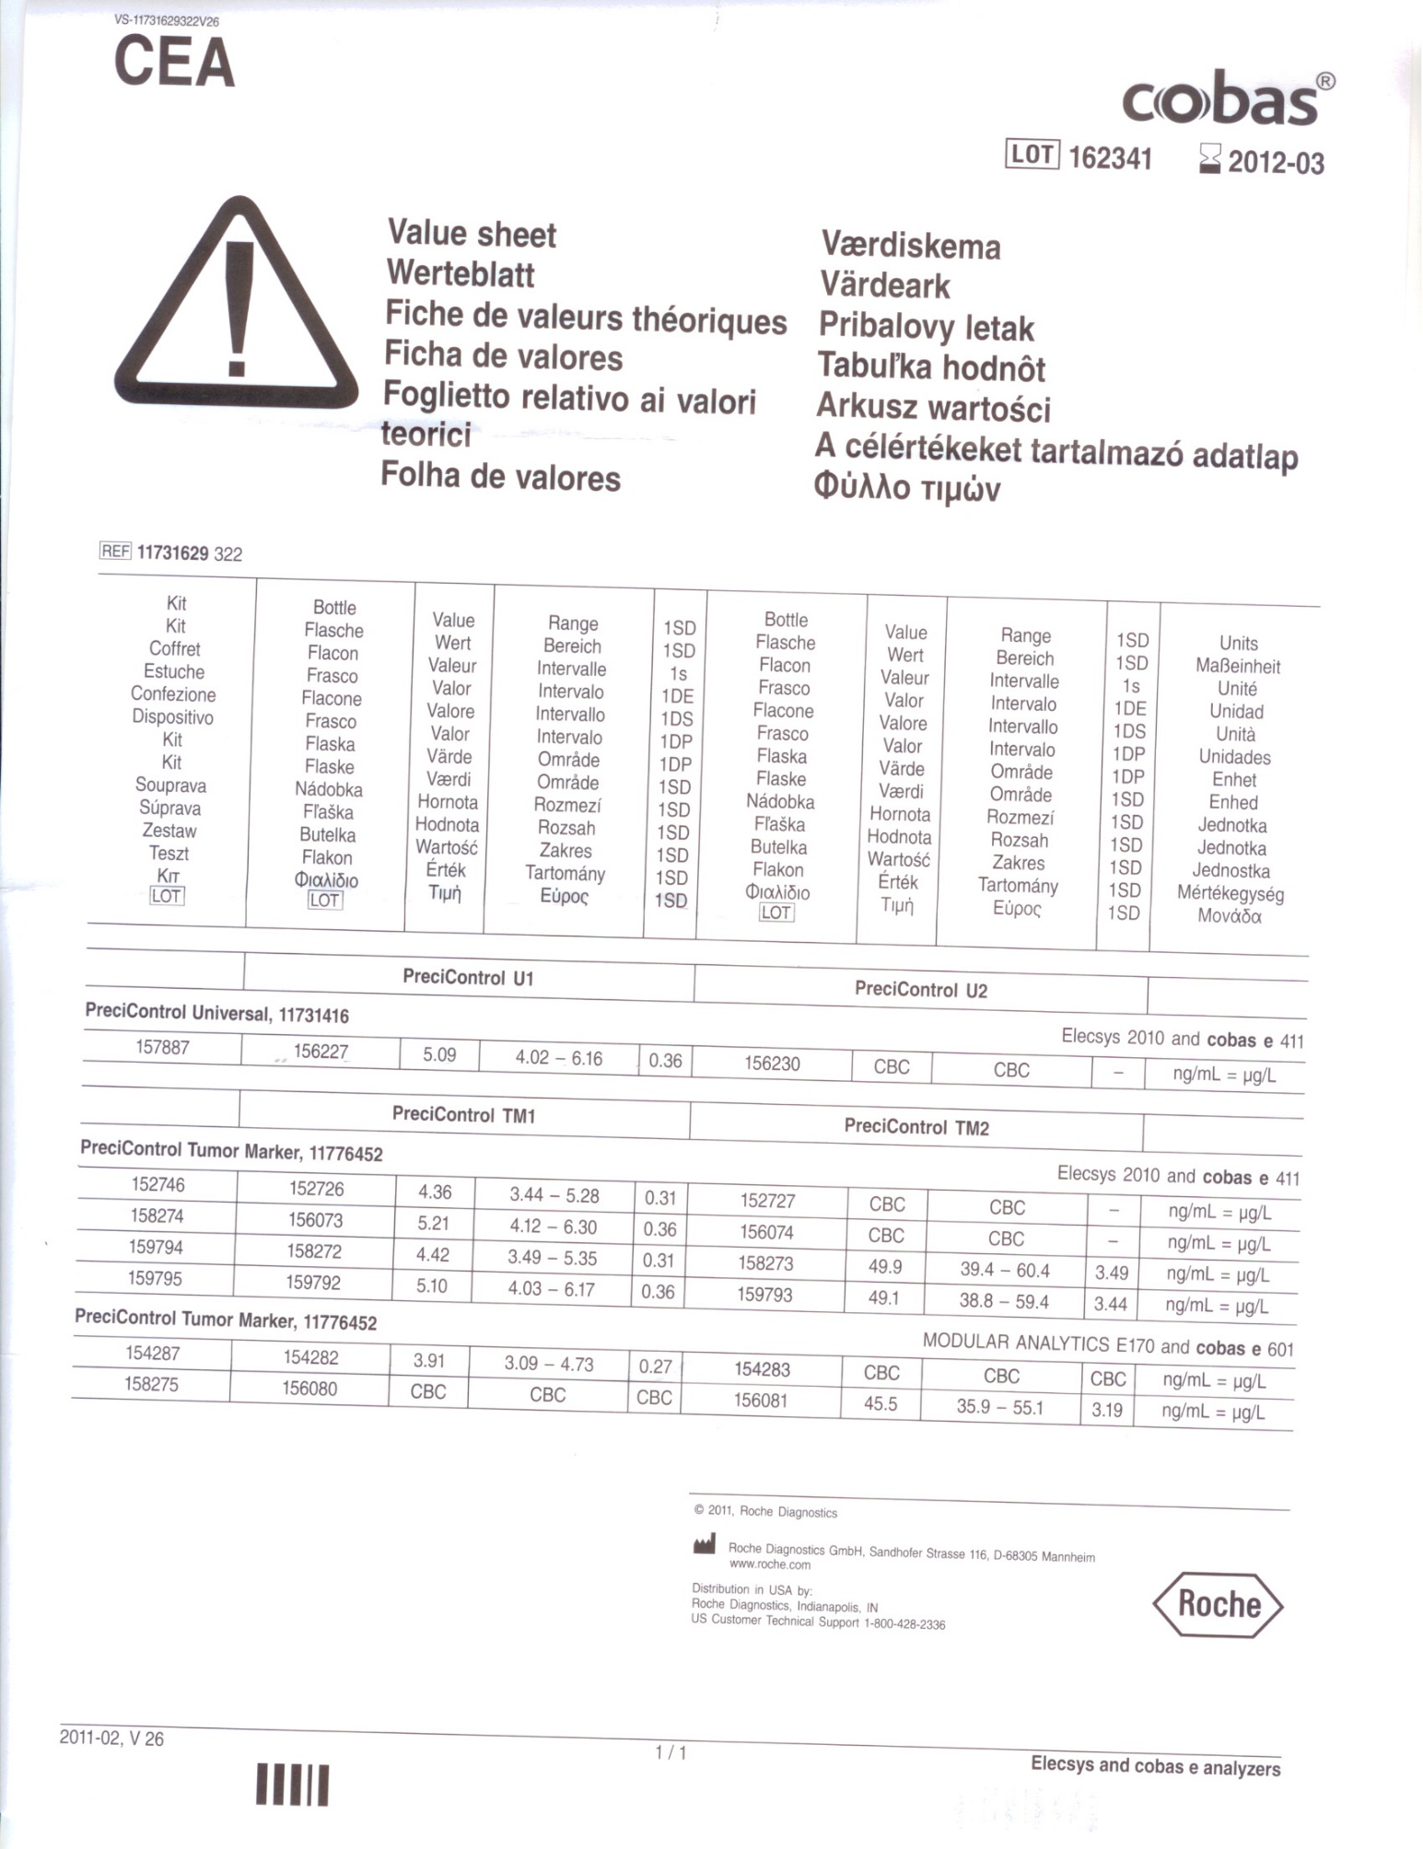

Appendix B.

Symbols Sheet
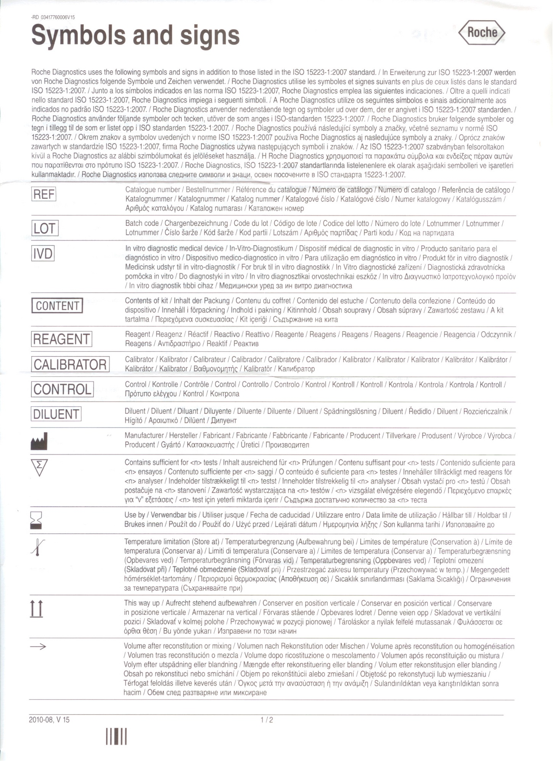

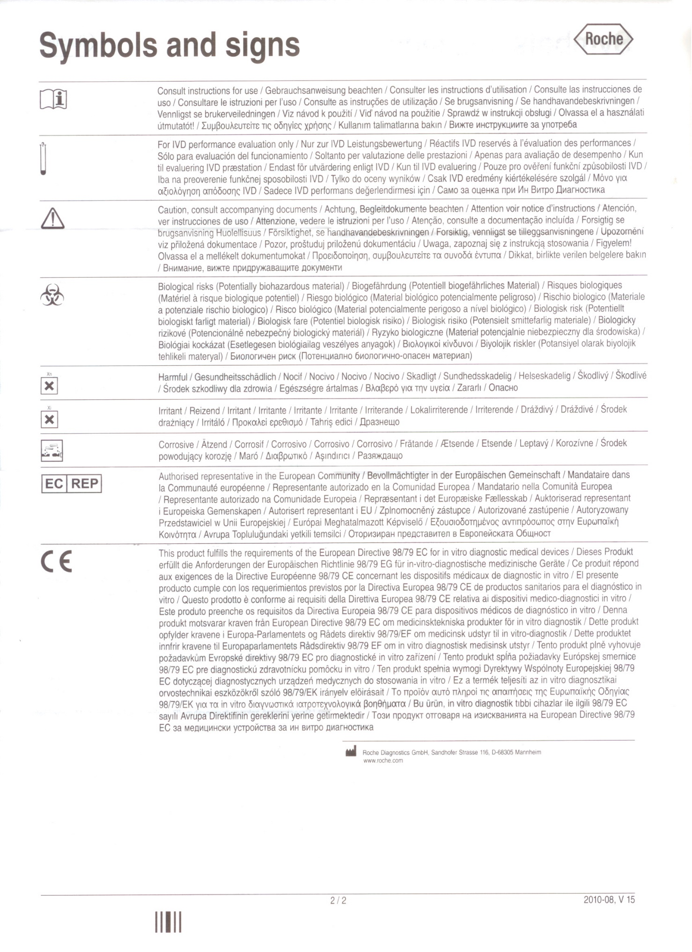

Appendix C.

Testates

With my signature I testify that I have read and understood this SOP.

Name | Date | Signature

